**Fundamental Niche modeling**

Still to do / check

Overall:

* Change number of Rmd files as they are different in the book?
* Delete folder Tutorial if no longer needed, but double check before deleting
* Double check for differentiating the different Mahalanobis approaches (check all files after 04)
* Consider changing the sub titles: instead of sorting it by species, sort it by type of calculation / plot that is done (there are currently some inconsistencies)
* Original functions still need proper descriptions
* Original functions have different examples than tutorial functions – **they are not the same**!   
  If they are deleted, the code for the examples will be lost
* Ellipses in ggplot have no legend

In tutorial:

00 Introduction

* The introduction is currently the index
* Issue that code for references no longer works -> currently just copied text of references
* in.el in table was named the other way around and although I changed it, it reverted back -> double check again

01 Initial Data

* (added table with tolerance limit)
* Check which table for tolerance limit is better (either use print code or implemented table), then delete unnecessary code

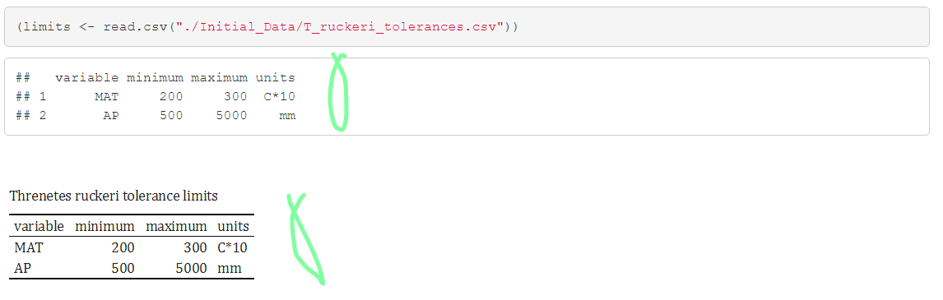

02 Get Ecoords

03 Plot Gspace Espace

04 Mahalanobis model

* Needs some more explanation
* Double check for differentiating the different Mahalanobis approaches
* Has no “Dependencies” section as the libraries are only needed for the extra calculations
* Double check the sub titles

05 Eellipse

06 rsampleM

* Comment in line 155: <!-- what does "probability of selecting a point" here mean? -->
* Took out dependencies/libraries `rgeos`, `tools` as it does not seem like they are needed at all

07 Inside ellipse

* Figure captions need to be changed for all figures, they are suboptimal

08 Weighted normal distribution

* Took out dependencies/libraries (tools) and (scales)
* No legend for ggplot ellipses

09 Projecting Nf into Gspace

10 Evaluation method

* Line 54 to 56 needs some editing
* No dependencies defined because it has many functions and it is not clear to which the dependencies belong

11 Bayesian method

* Needs better description